**6.59 – I-Beam in Torsion**

Total Deformation - .07m max

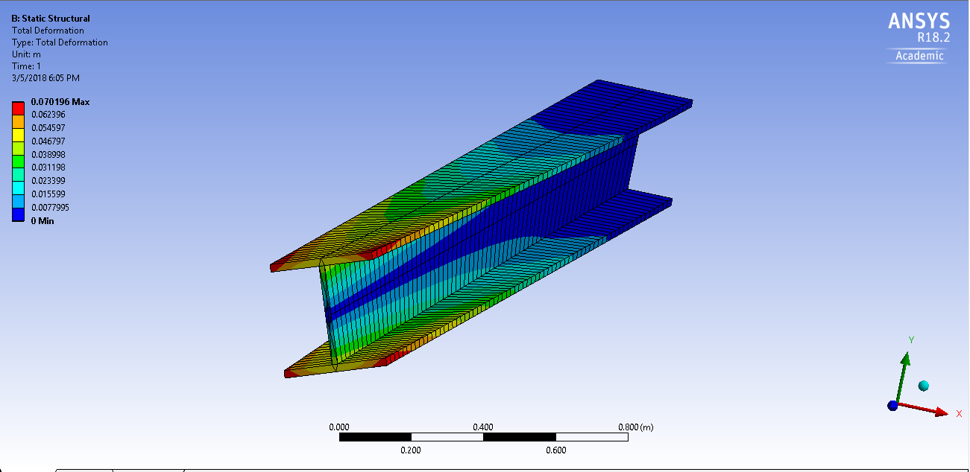

Shear Stress – 44.75 MPa max

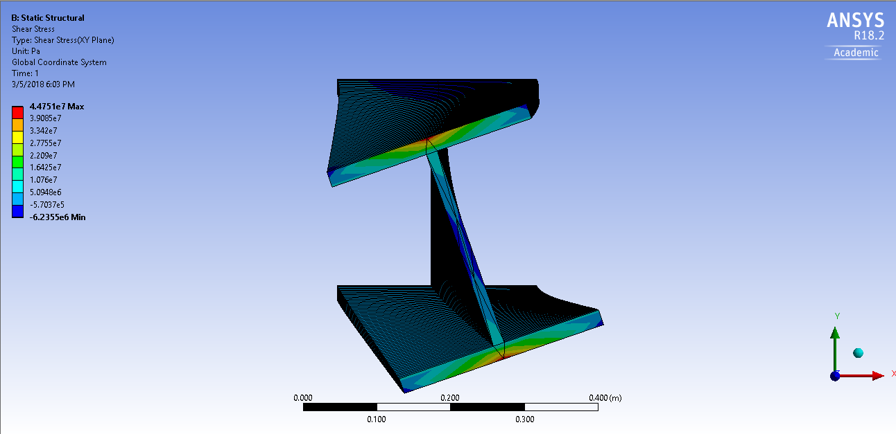

Equivalent Stress – 177.9 MPa Max

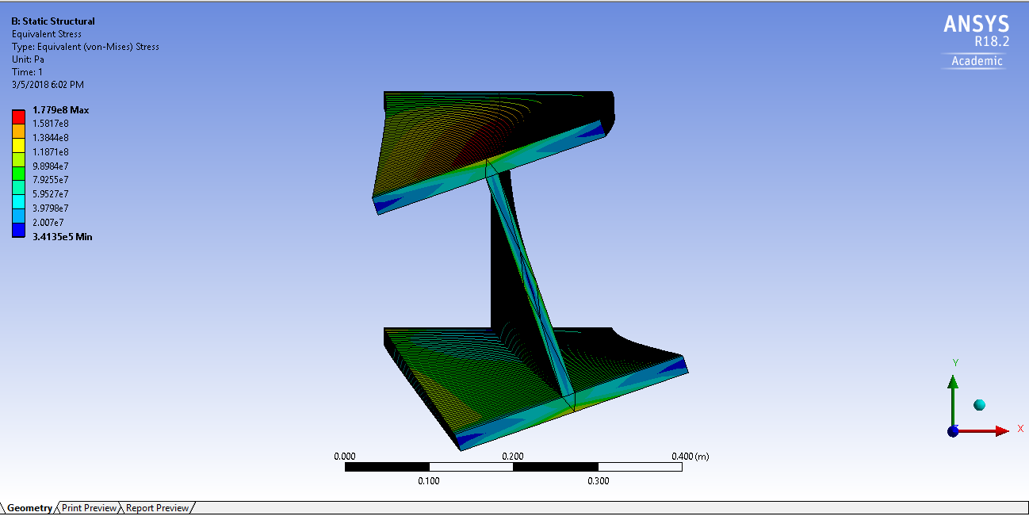

**6.10 – Thin Wall Compartment**

Total Deformation - .002m max

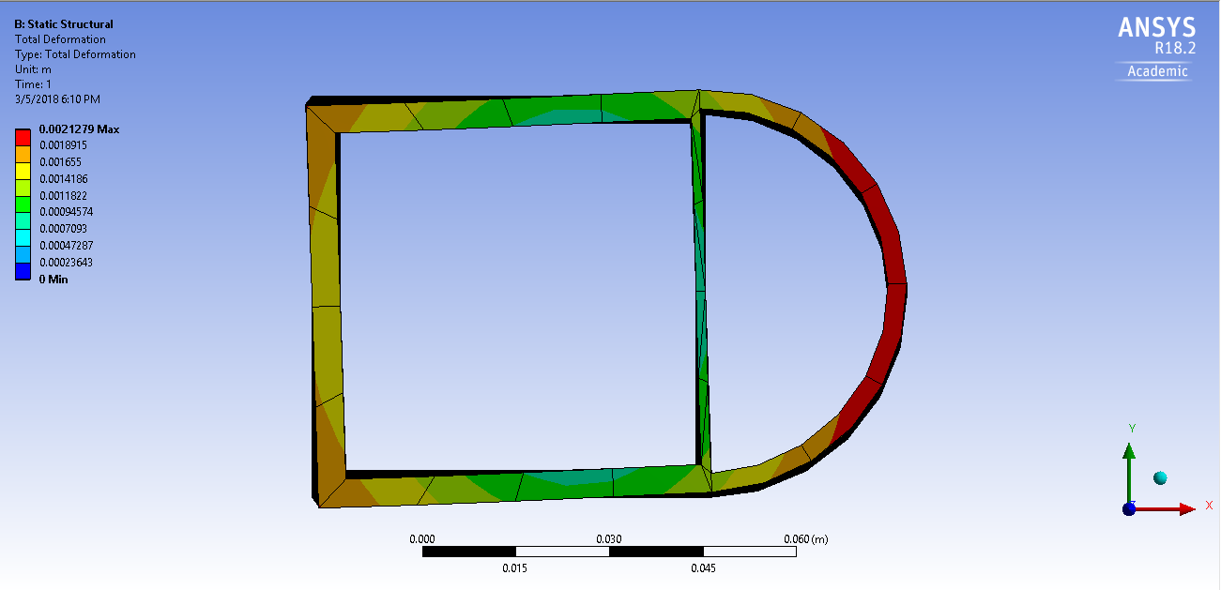

Shear Stress – 69.4 MPa max

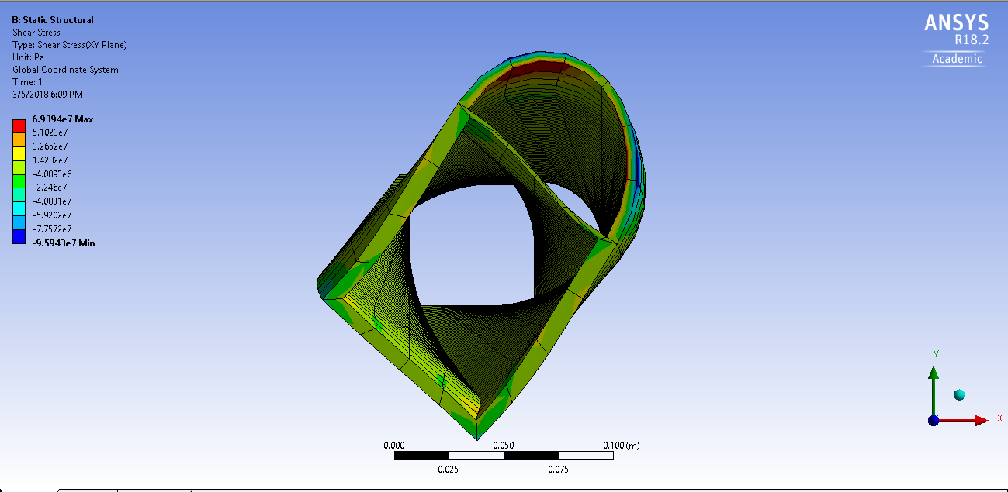

Equivalent Stress – 297.9 MPa max

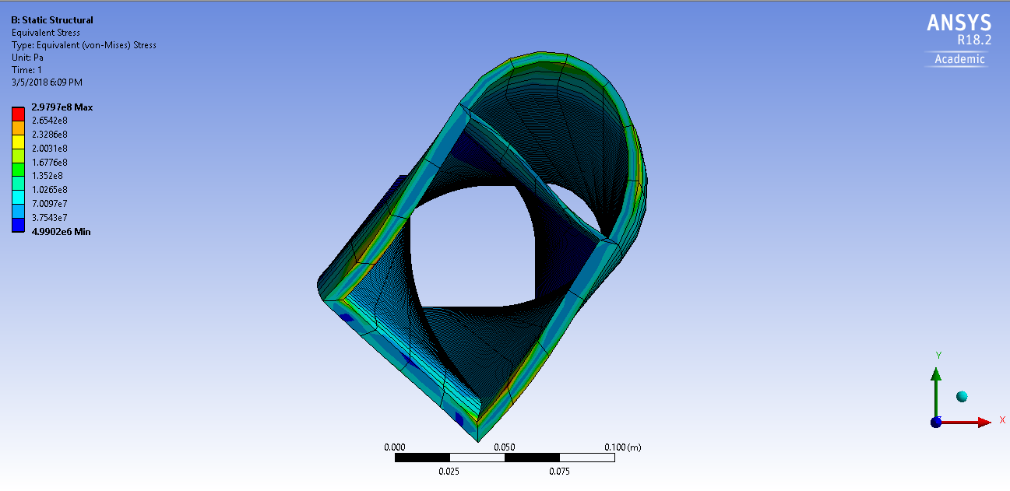

**Example – Cylinder in Plastic Torsion**

Needs a finer mesh, don’t know how

Deformation - .003m Max

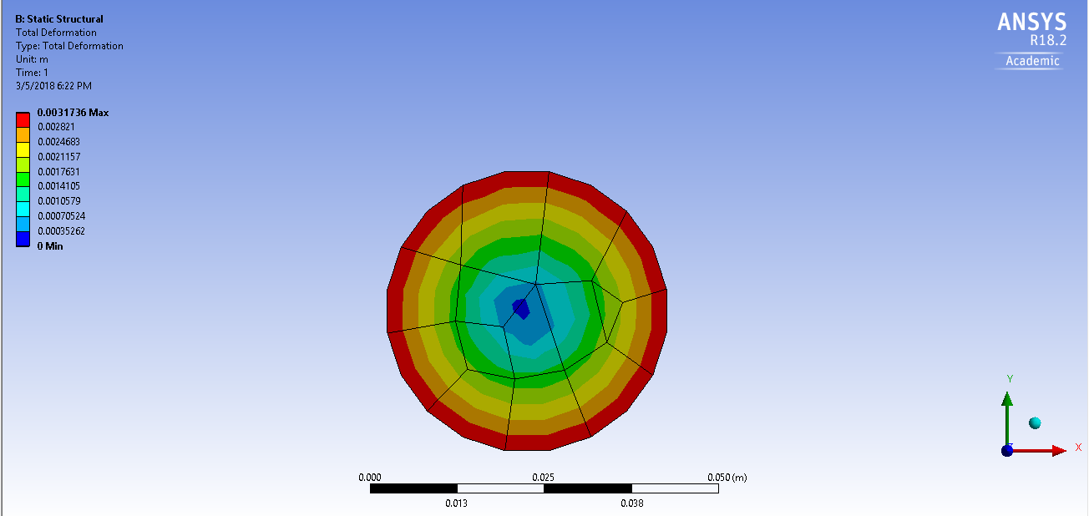

Shear Stress – 15.48MPa max, -14.8MPa min

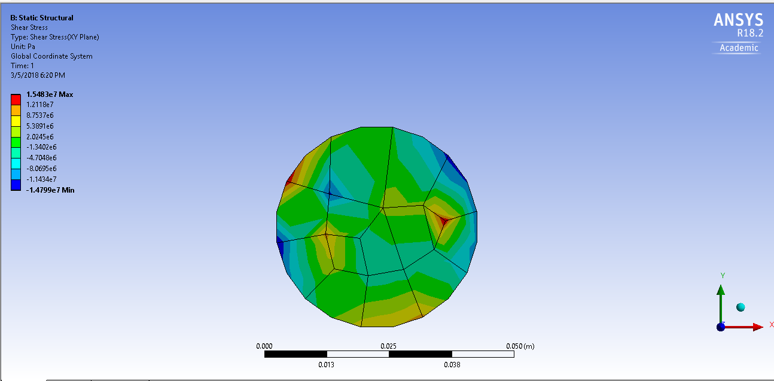

Equivalent Stress – 312.2 MPa max

